- 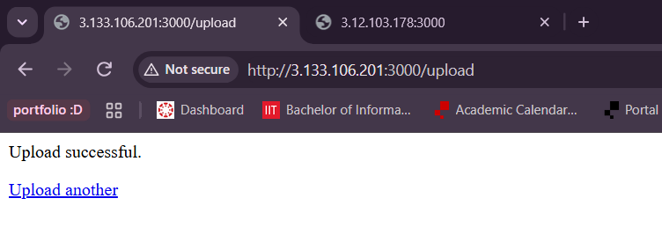
- 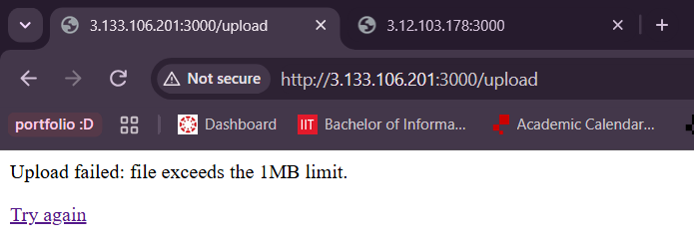
- 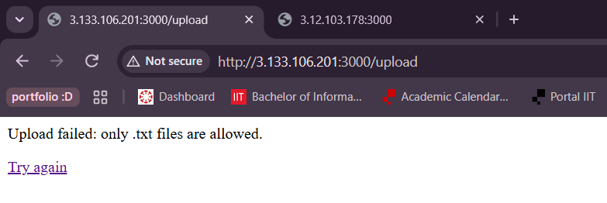
- 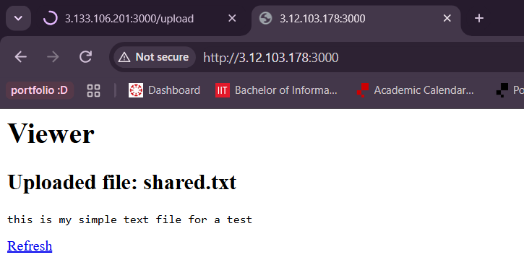
- 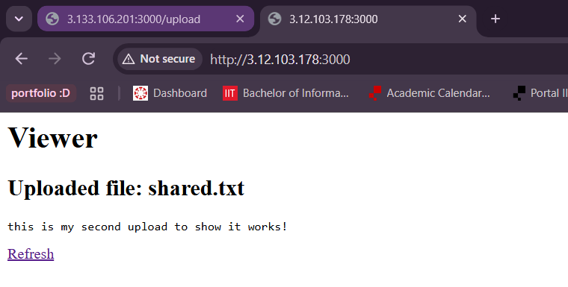
- 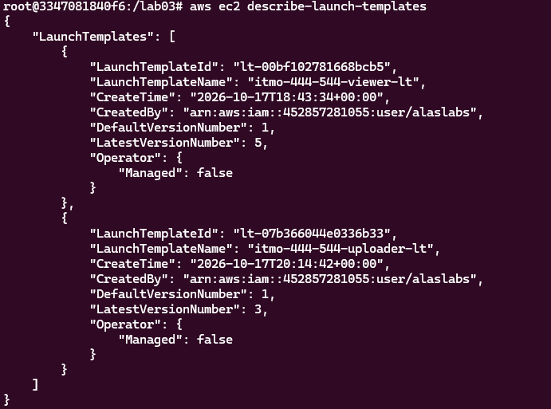
- My docker broke while I tried and I fear it will break again, and this is already late enough + I need to work on todays lab so in true coder words: just trust me bro
- 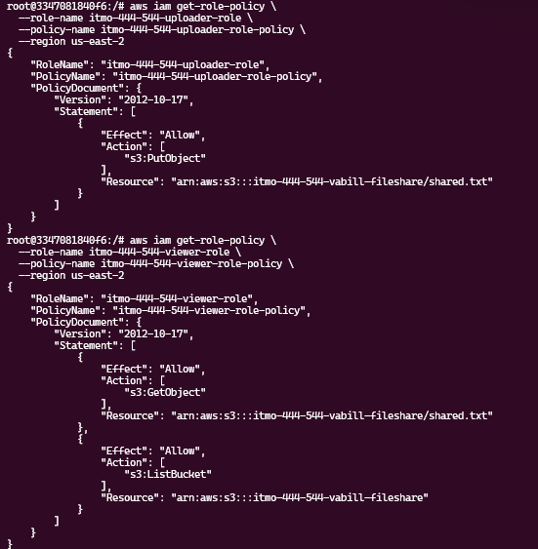
- 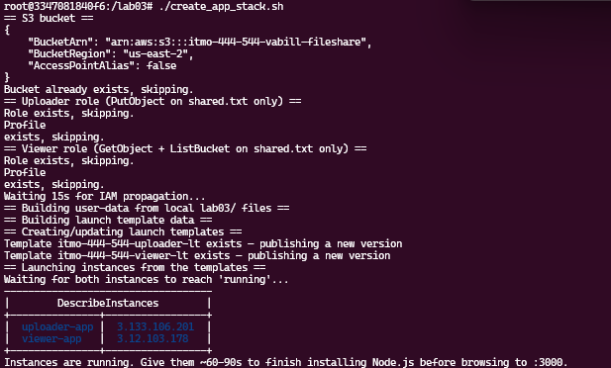
- 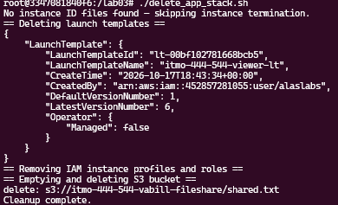
- The uploader and viewer use separate IAM roles to follow the principle of least privilege, which means each application only receives the permissions it needs to perform its job. The uploader role only has permission to upload to the bucket, while the viewer role only has permission to read the files. Keeping the roles separate reduces security risks because if one application is compromised, an attacker cannot automatically use that role’s permission to perform the other application’s actions. This makes the system more secure and easier to manage.
- Embedding the application code directly into the EC2 instance’s user-data script allows the instance to receive its code during startup without downloading it from Git or S3. This eliminates the need for Git or S3 credentials just to retrieve the code and reduces the risk of exposing sensitive credentials.

